**Answer to the Question no: 01**

#include <stdio.h>

#define MAX_SIZE 100

int main()

{

char text1[MAX_SIZE];

char text2[MAX_SIZE];

int i;

printf("Enter any string: ");

gets(text1);

for(i=0; text1[i]!='\0'; i++)

{

text2[i] = text1[i];

}

text2[i] = '\0';

printf("First string = %s\n", text1);

printf("Second string = %s\n", text2);

printf("Total characters copied = %d\n", i);

return 0;

}

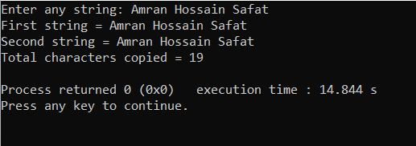

**Answer to the Question no: 02**

#include <stdio.h>

#define MAX_SIZE 100

int main()

{

char str1[MAX_SIZE], str2[MAX_SIZE];

int i, j;

printf("Enter first string: ");

gets(str1);

printf("Enter second string: ");

gets(str2);

i=0;

while(str1[i] != '\0')

{

i++;

}

j = 0;

while(str2[j] != '\0')

{

str1[i] = str2[j];

i++;

j++;

}

str1[i] = '\0';

printf("Concatenated string = %s", str1);

return 0;

}

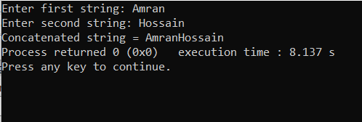

**Answer to the Question no: 03**

#include <stdio.h>

int compare(char[],char[]);

int main()

{

char str1[20];

char str2[20];

printf("Enter the first string : ");

scanf("%s",str1);

printf("Enter the second string : ");

scanf("%s",str2);

int c= compare(str1,str2);

if(c==0)

printf("strings are same");

else

printf("strings are not same");

return 0;

}

int compare(char a[],char b[])

{

int flag=0,i=0;

while(a[i]!='\0' &&b[i]!='\0')

{

if(a[i]!=b[i])

{

flag=1;

break;

}

i++;

}

if(flag==0)

return 0;

else

return 1;

}

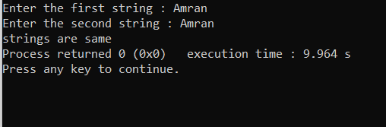

**Answer to the Question no: 04**

#include <stdio.h>

#define MAX_SIZE 100

int main()

{

char str[MAX_SIZE];

int i = 0;

printf("Enter any string: ");

gets(str);

printf("String before toggling case: %s", str);

for(i=0; str[i] != '\0'; i++)

{

if(str[i]>='a' && str[i]<='z')

{

str[i] = str[i] - 32;

}

else if(str[i]>='A' && str[i]<='Z')

{

str[i] = str[i] + 32;

}

}

printf("String after toggling case: %s", str);

return 0;

}

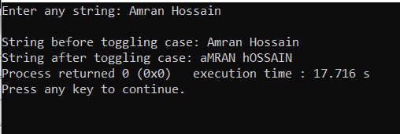

**Answer to the Question no: 05**

#include <stdio.h>

#define MAX_SIZE 100

int main()

{

char text[MAX_SIZE];

int i;

int count= 0;

printf("Enter any string: ");

gets(text);

for(i=0; text[i]!='\0'; i++)

{

count++;

}

printf("Length of '%s' = %d", text, count);

return 0;

}

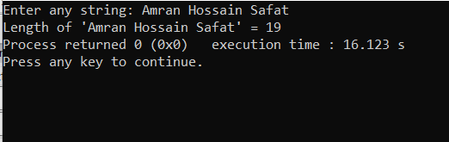

**Answer to the Question no: 06**

#include <stdio.h>

int main()

{

char str[100];

int i;

int words=1,characters=0,space=0;

printf("Please enter the string \n");

gets(str);

for(i=0; str[i] != '\0'; i++){

if(str[i]!=' '){

characters++;

}

else if(str[i]==' ' || str[i] != '\n' || str[i] != '\t'){

words++;

}

}

printf("\nTotal words: %d ",words);

printf("\nTotal characters: %d",characters);

printf("\nSpace: %d ",(words-1));

getch();

return 0;

}

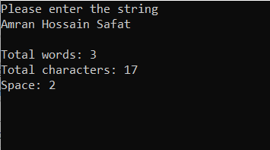

**Answer to the Question no: 07**

#include <stdio.h>

int main()

{

char A[50];

int V;

int C;

V = C = 0;

printf(" Enter a string: ");

fgets(A, sizeof(A), stdin);

for (int i = 0; A[i] != '\0'; ++i) {

A[i] = tolower(A[i]);

if (A[i] == 'a' || A[i] == 'e' || A[i] == 'i' ||

A[i] == 'o' || A[i] == 'u') {

++V;

}

else if ((A[i] >= 'a' && A[i] <= 'z')) {

++C;

}

}

printf(" number of Vowels: %d", V);

printf(" Number of Consonant: %d", C);

return 0;

}

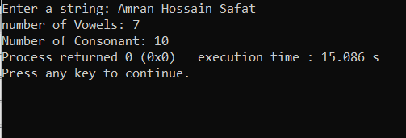

**Answer to the Question no: 08**

#include <stdio.h>

#define MAX_SIZE 100

int main()

{

char str[MAX_SIZE];

int alphabets, digits, others, i;

alphabets = digits = others = i = 0;

printf("Enter any string : ");

gets(str);

while(str[i]!='\0')

{

if((str[i]>='a' && str[i]<='z') || (str[i]>='A' && str[i]<='Z'))

{

alphabets++;

}

else if(str[i]>='0' && str[i]<='9')

{

digits++;

}

else

{

others++;

}

i++;

}

printf("Alphabets = %d\n", alphabets);

printf("Digits = %d\n", digits);

printf("Special characters = %d", others);

return 0;

}

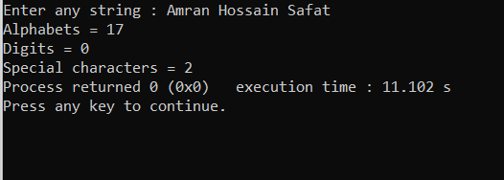

**Answer to the Question no: 09**

#include <stdio.h>

#include <string.h>

int main()

{

char a[100], b[100];

printf("Enter a string to check if it's a palindrome\n");

gets(a);

strcpy(b, a);

strrev(b);

if (strcmp(a, b) == 0)

printf("The string is a palindrome.\n");

else

printf("The string isn't a palindrome.\n");

return 0;

}

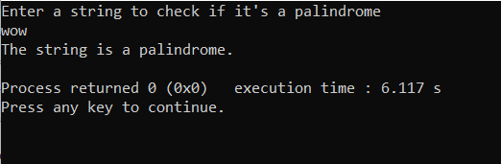

**Answer to the Question no: 10**

#include <stdio.h>

int main()

{

char str[100],ch;

int i,j,l=0;

printf("Input the string : ");

fgets(str, sizeof str, stdin);

for (i = 0; str[i] != '\0'; ++i)

{

l++;

}

for(i=1;i<l;i++)

{

for(j=0;j<l-i;j++)

{

if(str[j]>str[j+1])

{

ch=str[j];

str[j] = str[j+1];

str[j+1]=ch;

}

}

}

printf("After sorting the string appears like : %s",str);

return 0;

}

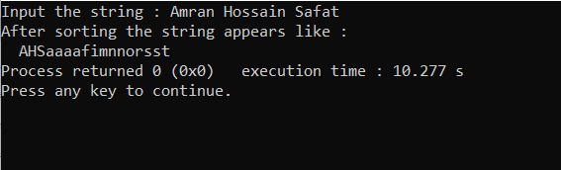

**Answer to the Question no: 11**

#include <stdio.h>

#define MAX_SIZE 100

int main()

{

char str[MAX_SIZE];

char toSearch;

int i;

printf("Enter any string: ");

gets(str);

printf("Enter any character to search: ");

toSearch = getchar();

for(i=0;str[i]!='\0';i++)

{

if(str[i] == toSearch)

{

printf("'%c' is found at index %d\n", toSearch, i);

}

}

return 0;

}

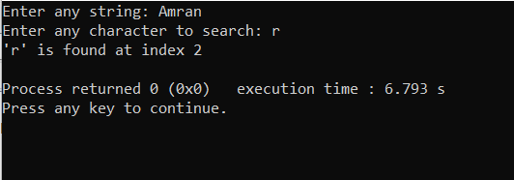

**Answer to the Question no: 12**

#include <stdio.h>

#include <string.h>

void swap(char *x, char *y)

{

char temp;

temp = *x;

*x = *y;

*y = temp;

}

void permute(char *a, int l, int r)

{

int i;

if (l == r)

printf("%s\n", a);

else

{

for (i = l; i <= r; i++)

{

swap((a+l), (a+i));

permute(a, l+1, r);

swap((a+l), (a+i));

}

}

}

int main()

{ char a[] = "ABC";

permute(a, 0, 2);

getchar();

return 0;

}

